
Supersaver Prototype Reactions Round II/ Research Report
Jan 2023 | DRI: Kelly Peterson Working Team: Ishaan Kansal Razeen Jivani Khalil Grell Jordan Caines Meghan Desai Francesca Ravella Jessica Reed Kevin Fu Peter Sergel Matt Detiveaux Research Brief

| Context: There are ~100M Cx US-wide that place <2 orders a month on DoorDash. These “Occasional Cx” represent a significant opportunity for growth for DD. One of the major issues with DoorDash identified is affordability, which is also a challenge for other Cx segments. Within the realm of affordability Cx noted high fees, and high total cost at checkout as some of the greatest contributing factors.

The SuperSaver feature offers to provide a key affordability lever for non-DashPass Cx by allowing $0 delivery fees for the 3 restaurants that Cx assign to the SuperSaver program. Initial tests of the design showed significant Cx confusion around what SuperSaver was and how it works. This research aims to ensure that the updated designs and potential names are clear before launching the experiment.
| Research Questions:
- What areas of confusion, friction or frustration exist in the sign up, transfer and check out process?
- How do Cx feel about having to re-enter their information when signing up for DoorDash pharmacy?
- How do Cx feel about the medicine cabinet?
- Are Cx interested in using DoorDash pharmacy after exposure to the prototype?
- How clear is the product name? What action does the name spark? Does the name align with the product?

| Prototype Link(s)
Pick 3 and Save
Fave and Save
New link added after Cx feedback: Star and Save v1, Star and Save v2
**Please note, links were updated live between sessions to drive better clarity and awareness. Thank you Ishaan Kansal
| Sample:
- N= 10 Occasional Cx (excluding marketing where PAD/EPIC tests are currently live)
  - Sample was spread among different geographies, ages, genders as much as possible
  - One DashPass Cx snuck into the sample (total N=11). Feedback on clarity of the program is included in the summary below,, feedback on program interest/impact is excluded from the below
  - Details on sample breakSuperSaver Round II Trackerdown, design exposed and recording link can be found here:
| Insights & Recommendations
Recommended Name: Star and Save
- The “Name Star and Save” came up in an interview when a Cx was explaining why they didn’t know they had to click on the star icon, as recommended by research this name was added into testing
- Having the number 3 in the name confused Cx and make them think they had to take 3 actions (order from all 3 restaurants, order 3 items) to get a discount
- Cx who were exposed to “Fave and Save” or “Pick 3 and Save” did not quickly understand the connection to the icon, Cx exposed to “Star and Save” made the connection more quickly
- Cx thought the heart icon that is already available on DoorDash was a favorite icon or associate “favorite” with a heart
- Secondary option is “Pick and Save” if “Star and Save” does not pass legal/trademark approval
Use of color/font/imagery is critical to ensure carousel text stands out
- 8 out of 10 Cx scrolled past the carousel and did not realize the promotion
  - 2 Cx noticed it later in the flow due to the tooltip, but they did not understand what the program was and felt it was a one time promotion
  - 1 Cx mentioned that she typically ignores the tooltips because there are so many on the app
  - The 2 that recognized it did so because it was v2 of Star and Save where additional color was added to the carousel
  - A handful of respondents mentioned that the app is crowded and they scroll quickly
- Previous prototype research shows that Cx are experiencing banner fatigue, suggesting that banners can be complementary but not the primary source of information
- Cx that learned about the offer elsewhere had a more difficult pathway to learning what the program is/how it works
- Example of more impactful approach to carousel:
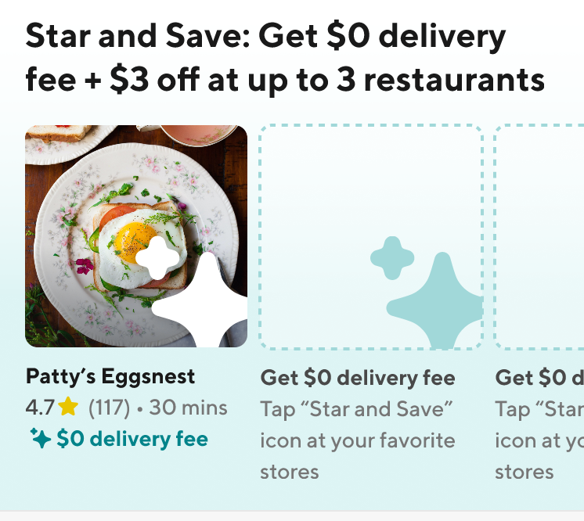
Make sure the “unlimited” nature of the program is clear
- Cx did not initially understand that:
  - The offer was valid anytime you shopped at a starred/picked/faved store
  - The offer was valid for any restaurant on the app
- Versions that explicitly called out unlimited and any had better cognition for these concepts
- These concepts amplify Cx interest in the offering and potential for impact
- Make sure it is covered in the tooltip as well
Include a tooltip at checkout to explain the $3 off
- 7 out of 10 Cx expected to see the $3 off the subtotal rather than the service fees
  - Only one Cx was bothered by this difference, most though it was ok, but the subtotal would be better
- Cx look at the subtotal and the final subtotal (red bar) so the savings do not feel as strong when comparing those 2 numbers
- The ideal scenario would be to see a (-$3.00) in their checkout page, similar to if a credit was applied
Make it clear it’s not DashPass, use a different color if possible
- 2 Cx confused the offer with DashPass and were less interested in exploring/participating
  - One Cx previous had DashPass and though it did not give her that much value and she thought this was telling her to sign up again
  - One Cx thought it was an upsell for DashPass because they thought the star logo was the DashPass logo when scrolling through
Make sure that tooltip still shows up when filters are used or if someone searches for a Rx
- 48% of orders Cx already know the type of cuisine they want to order
- 37% of orders Cx already know the restaurant they want to order from
- Half of Cx interviewed initially focused on, attempted to click on or discussed clicking on a filter/cuisine carousel to replicate a “typical order”
For some Cx alternative solutions focused on cooking, healthy eating and quality will be needed
- 10 out of 10 respondents stated they felt interested in or excited about this offer
- 6 out of 10 respondents stated they felt it would increase their order frequency
  - Cx who prefer to cook, have a partner that prefers to cook or have experienced quality issues were hesitant to say this would impact their likelihood to place orders
  - Some Cx indicated that they expected there to be a minimum number of orders placed to keep the offer valid

